# COMP215 –Lab04 – CSS Exercise 3 – Three Column Layout using CSS

## Readings:

* <http://www.w3schools.com/css/css_positioning.asp>
* <http://www.w3schools.com/css/css_float.asp>

## **Demonstration**: Using CSS to Create a 3-Column Layout with Header and Footer

|  |  |
| --- | --- |
| In this exercise you will create a web page that uses a three column layout, with a header and footer that does not rely on tables for formatting. This is a fairly common technique for many Web pages. Here’s an example: | Image from book |

|  |  |
| --- | --- |
| This page is divided into 5 basic sections: a header region at the top, a footer region at the bottom, and three column areas for content across the center: | 3col |

## Let’s Try it

**1. Create the stylesheet**

Start by declaring the three columns in a file called **threecol.css** in your web site:

#left {

float: left;

width: 210px;

border: dashed blue

}

#right {

float: right;

width: 200px;

border: dashed blue

}

#center {

margin-left: 210px; /* 218px works better, why? */

margin-right: 210px;

border: solid blue

}

**2. Create the page**

Now create a page called “sample3col.htm” in your web site that uses the **threecol** style sheet.

Place the three columns onto your page like this:

<div id="left">

<!--left content -->

Left

</div>

<div id="right">

<!--right content -->

Right

</div>

<div id="center">

<!--center content -->

Center

</div>

This gives you a page that looks something like this:



Notice the one div floats to the left and takes up 210px, other floats to the right and the third sits in the middle taking up the remainder.

**3. Add the header**

Now we can add the header with another style:

#top {

margin: 20px;

padding: 10px;

text-align: center;

background: #ccc;

}

And another div:

<div id="top">

<!header content -->

Header

</div>

Now you should have this page:

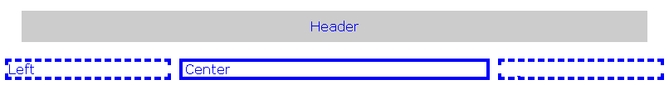

**4. Add the footer**

Ok, time for the footer:

#footer {

background: #ccc;

margin: 20px;

text-align: center;

}

And:

<div id="footer">

<!footer -->

Footer

</div>

This gives us this page:

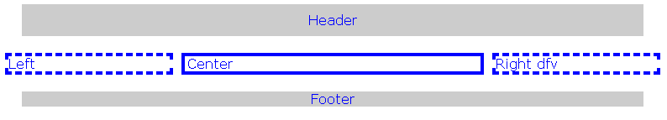

The problem with this page is that the left and right columns float “on top” of the page, the position of the footer is determined solely by the height of the center column.

Look what happens if you add content to the left div, like this:

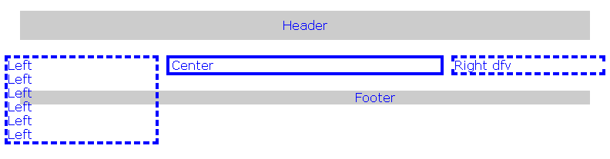

That’s not really what we wanted. One trick is to simply modify the footer style so that it looks like this:

#footer {

background: #ccc;

margin: 20px;

text-align: center;

clear: both;

}

This forces the footer to appear below anything floating to the left or the right. (Clears the left and right of the footer div). For cases where the DIV contents overflow, investigate the “clearfix hack” described in the w3schools CSS Float tutorial: <https://www.w3schools.com/css/css_float.asp>

## Lab Exercise: Redo your homepage to avoid misusing Tables for Layout

Use this approach to create a CSS version of your home page from Lab01. Remove the tables and restructure the layout using DIVs and CSS